**CONCEPTS OF ETHICAL HACKING LAB**

**WEEK – 7**

**Jcryptool and Demonstration of Asymmetric key Crypto Algorithm, Hash and Digital Signature/PKI**

Demonstrating practical usage of asymmetric key cryptography algorithm and hash using Jcryptool.

**Requirements:**

1. Jcryptool.

**Procedure:**

1. Download Jcryptool from www.cryptool.org and extract it.
2. Run JCrypTool.exe as administrator.
3. Open a new text and save it after writing a message on it.
4. Now open the Algorithms option from the upper left corner and select the RSA algorithm from Asymmetric algorithms.
5. Now create a New Key pair using the users name as contact name and user password.
6. 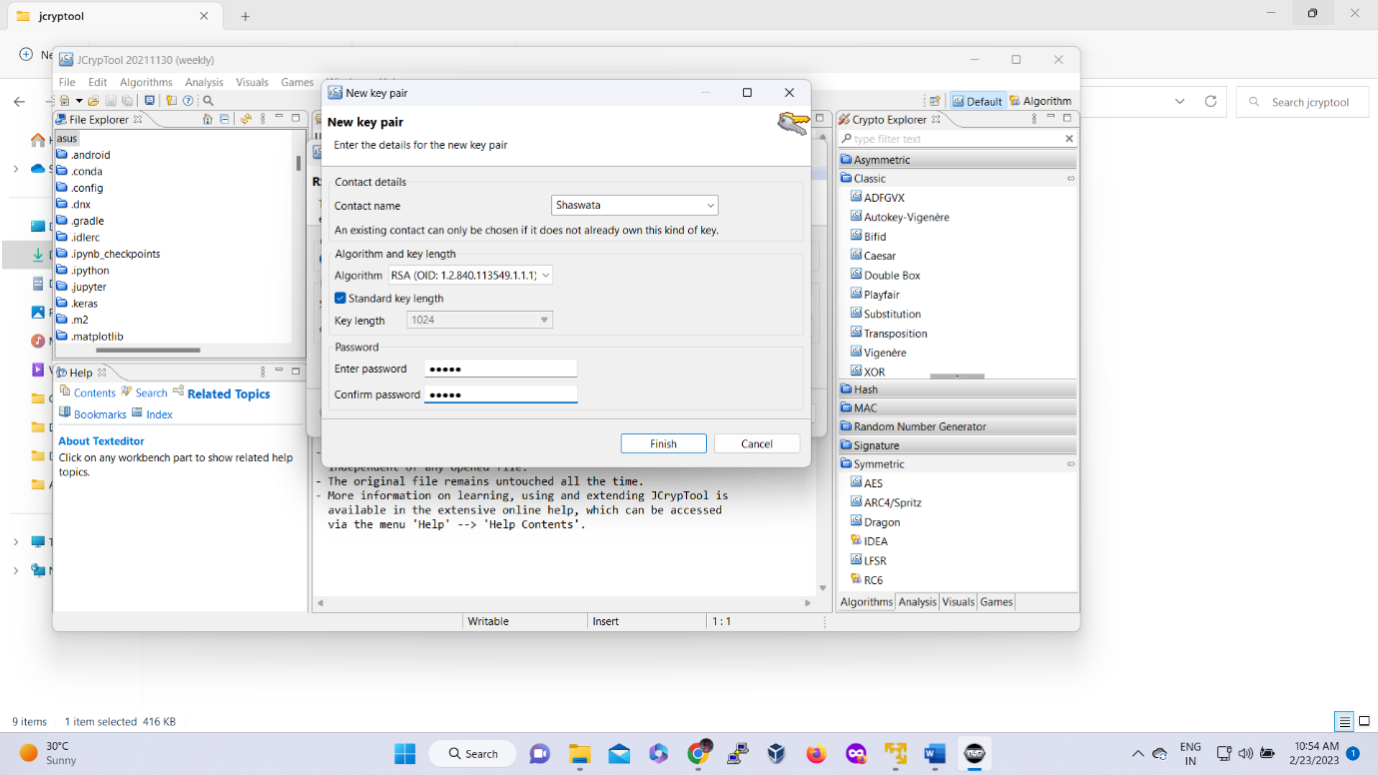
7. Encrypt the plain text/message using the new key pair.
8. Graphical user interface, application

   Description automatically generated
9. To decrypt the encrypted message again open the RSA algorithm and select the decrypt option.
10. Graphical user interface, application

    Description automatically generated
11. Users must choose the same key pair and give the user password when asked.
12. Graphical user interface, application

    Description automatically generated
13. For hashing of a message just select the preferred hashing algorithm which requires no further input.
14. Graphical user interface

    Description automatically generated

----END---